**Undergraduate Program of Clinical Medicine for International Students in Jining Medical University**

**1. About Jining Medical University**

Jining Medical University (JMU), established in 1952, is a medical higher education institution in Shandong Province. There are three campuses, namely, Jining Taibai Lake campus, Rencheng campus and Rizhao campus. JMU has two directly-affiliated hospitals, 12 indirectly-affiliated hospitals, over 160 practice teaching bases and 23 teaching community hospitals. The Affiliated Hospital of Jining Medical University is ranked as Shandong Provincial Regional Medical Centre. In 2015 the hospital passed the accreditation of JCI and level -6 certification of HIMSS.

There are 16 teaching units in JMU, including School of Science, School of Clinical Medicine etc., offering 29 majors such as clinical medicine, preventive medicine, and forensic science and so on. JMU has established a medical education-oriented structure, covering medicine, science, engineering, arts management, integrated with undergraduate education, and postgraduate education, continuing education, international education and Chinese-foreign cooperative education.

**2. About the Program**

**Undergraduate Program**: Clinical Medicine

**Duration:** 1 year (Chinese language proficiency program)+5 years

**Number of Enrollment**: 40-50 students

This program is offered exclusively to full-time international students. Applicants are supposed to undertake one-year Chinese language proficiency program.

**3. About the Application**

**3.1 Basic Conditions**

Applicants shall meet the following conditions:

(1) holder of foreign passport

(2) being mentally and physically healthy

(3) having obtained the official high school graduation certificate

(4) aged between 18-26 years old

(5) having a reliable economic guaranty and guarantor

(6) promising to follow Chinese Constitution, Chinese laws and regulations of Jining Medical University during his/her stay in China

(7) choosing Jining Medical University of his/her own willingness

**3.2 Language Requirement**

For the clinical medicine program taught in Chinese, applicants principally shall reach Level 4 of ILR (Chinese Language Proficiency Scales for Speakers of Other Languages) or pass the exam organized by the university after the one-year Chinese language proficiency program.

**3.3 Application Time**

May, 2024---Nov, 2024

**3.4 Enrollment Time**

May, 2024---Nov, 2024

**3.5 Application Materials**

* Application Form for International Students of Jining Medical University
* A copy of high school diploma
* High school transcript (all grades shall be above level C or above 60 %)
* College entrance exam scores
* Notarial Certificate of Non-criminal Punishment. A sealed photograph of the applicant should be affixed on the certificate
* One copy of passport information page valid for at least 18 months (with the name and passport number)
* One passport photo with white background
* One notarized Guardian’s Letter of Guarantee
* Foreigner Physical Examination Form issued by the local municipal hospital of host country. The applicant shall carry out the examination in strict accordance with the items required in the “physical examination form for foreigners” with missing items, such as no photo of the applicant, no seal on photo, no signature or seal of the attending physician and hospital, and no date of examination shall be deemed as invalid.

**3.6 Application Procedures**

* Applicants shall take the **entrance examination**.
* The admission list will be decided with reference to the comprehensive review of the applicants’ application materials, exam score, and health examination results, etc.
* Applicants who have received the **pre-admission letter** shall pay the seat reservation fee 5000 RMB. (The seat reservation fee will be counted into the first-year tuition fee once students are officially admitted and registered. Those who failed to register due to non-school factors after admission shall not be returned the seat reservation fee.)
* Applicants who have received the **admission letter** and **visa application form** shall pay in full the tuition and accommodation fee for the first year before getting officially registered as a student of Jining Medical University.

**4. About the Fees (RMB)**

|  |  |
| --- | --- |
| **Item** | **¥/YEAR/PERSON** |
| Chinese Language Proficiency Program | 13,000 |
| Clinical Medicine | 20,000 |
| Accommodation Fee | 3,600 |
| Residence Permit Fee | 400 |
| Annual Insurance | 800 |

Notes:

* Cost of water, electricity and network is extra. The accommodation fee will possibly be adjusted according to the changes of accommodation.
* A comprehensive medical insurance system has been implemented for international students in China, consisting of accidental injury and hospitalization insurance. It is compulsory for self-financing international students to purchase an insurance scheme meeting the standard designated by the Ministry of Education. The university will not accept an international student to register if he/she does not have such an insurance scheme.
* The university collects all dues by the academic year rather than the calender year. Fees for textbooks are not included in the tuition, which shall be collected in terms with the actual cost of books each year.
* All the fees mentioned are charged in Chinese Currency RMB (**¥**), and the unit is Yuan.

**5. Payment Method**

Please pay via the Campus Payment Platform, see the attachment for instructions. Please specify the applicant’s name and passport number.

**6. Scholarship**

Scholarships are awarded to outstanding students annually (excluding graduating students)

**7. Supplementary Provisions**

This brochure is published in both Chinese and English language. In case of any ambiguity, the Chinese version shall prevail. The university reserves all the rights for the final explanation of this brochure.

**8. Contact Information:**

Address: NO 133. Hehua Road, Taibaihu New District, Jining Medical University, Jining City, Shandong Province, 272067 P.R.China

Tel.: 0086-537-3616022

Website: www.jnmc.edu.cn

Email Address: jyghc@mail.jnmc.edu.cn

**附件：**

**Instructions on the Campus Payment Platform**

**Website：**

1. Log in the webpage of Jining Medical University (www.jnmc.edu.cn)，click“机构设置”-“职能部门”-“行政”-“财务处”，“网上缴费系统”on the left，then“校园统一支付平台”

Or <http://cwjf.jnmc.edu.cn/xysf/>

As it shows below:

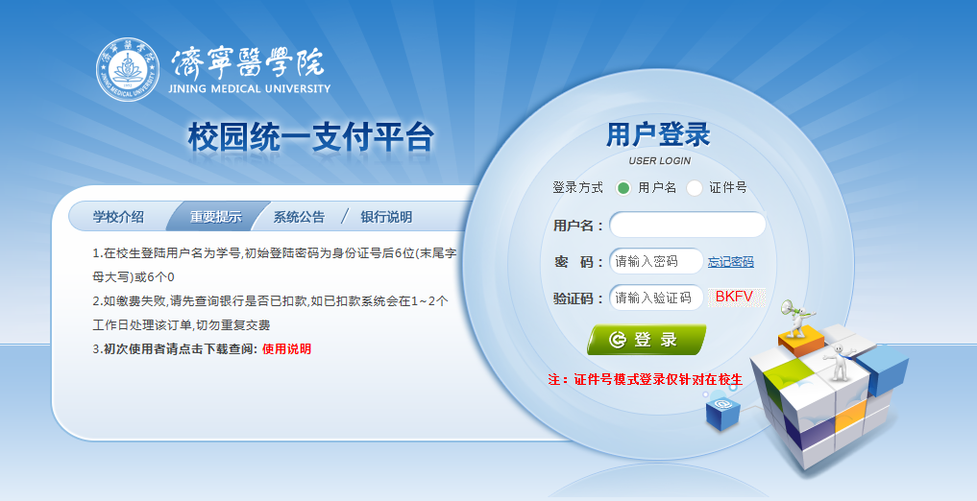

Username：Student number;

original password:000000

1. Check balance：

The page“当前费用”will show your balance and details.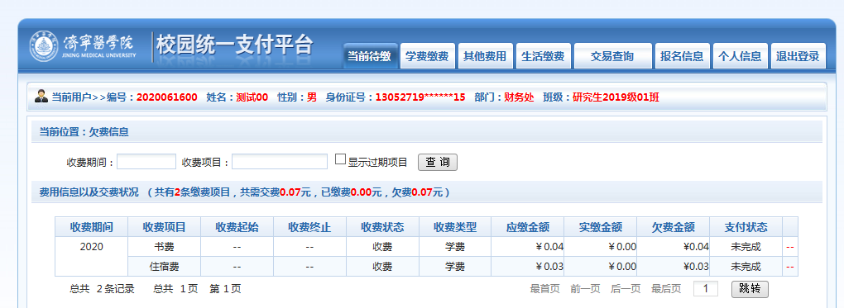

1. Payment：

Click“学费缴费”-“学宿费待缴”，the system will show the user’s arrears

and details. Select the item you need to pay, click“下一步”and follow

the instructions to complete the payment.

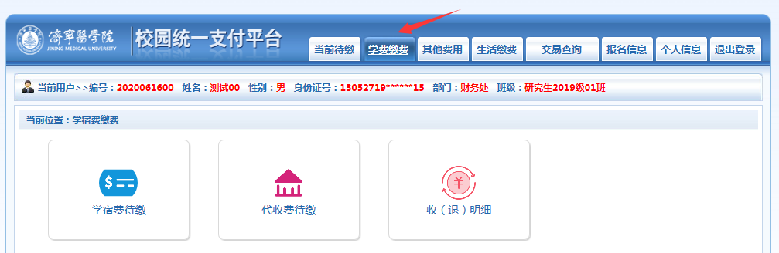

Note: “Agricultural Bank of China (ABC)” can be only paid via Palm Bank of ABC or K code.

1. Check your payment, download and print your electronic invoice：

点击导航栏的“交易查询”-“已缴费信息”，进入如下界面：

Click “交易查询”in the navigation bar and then “已缴费信息”, it will show the following page:

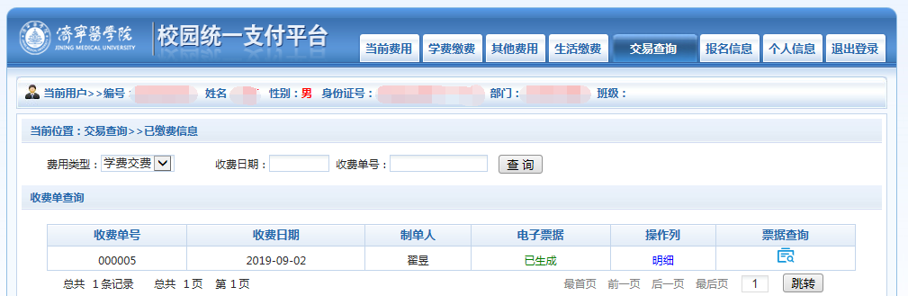

Click “明细”under “操作列”, your will see your payment details.

An E-invoice will be issued if you click the icon under “票据查询”on the right. You can download or print it if necessary.

**Mobile Phone**

1. Search and add the official account“济宁医学院财务处”via WeChat, or scan the code below (Picture 1) and add the account. Enter the account and click the menu“学生查缴费”-“学生缴费”as it shows in Picture 2.

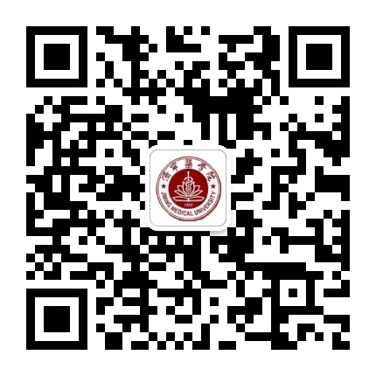 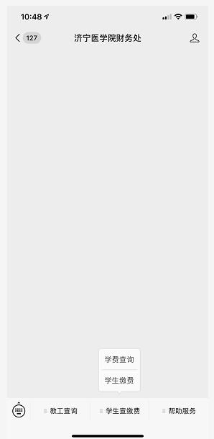

Pic 1：JMU Official Account Pic 2：Tuition Payment Menu

Register your personal information as it shows in Picture 3. Your username is your student number and the password is 000000. Click “关闭”after you complete registration. Return to the page in Picture 2 and click “学费缴费”

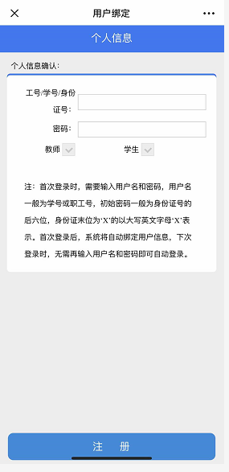 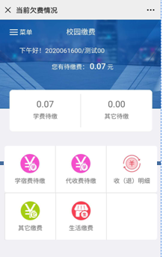

Pic 3: Registration Pic 4: Tuition Payment

2. Click “学宿费待缴”(Pic 4), the system will show the user’s arrears

and details. Select the item you need to pay and click “缴费”on the bottom right corner (Pic 5). Make sure the payment information is all correct, and confirm the payment. (Pic 6)

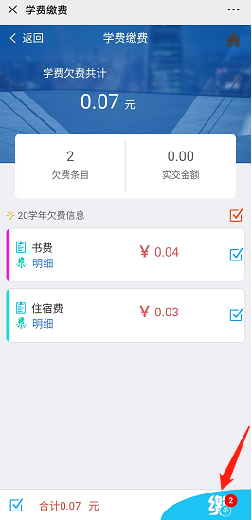 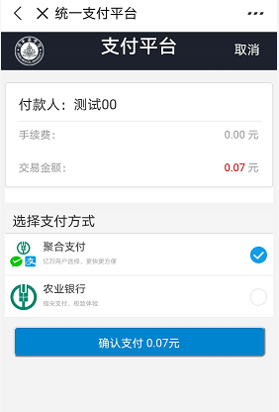

Pic 5: Payment Page Pic 6: Payment Confirmation

3. Check your payment, download and print your electronic invoice：

Click “菜单” on the top left corner on the homepage if you need to check you payment:

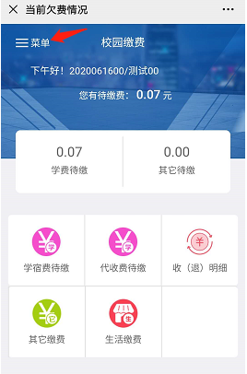 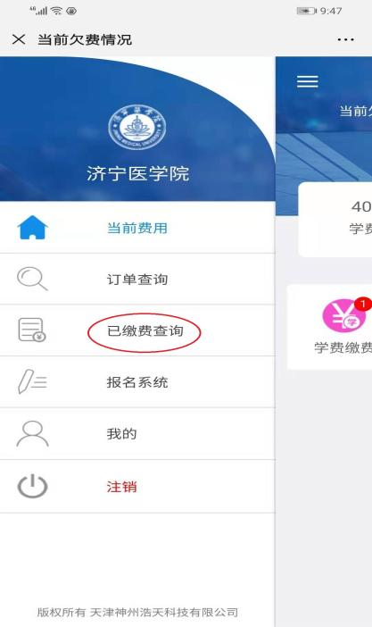

1. invoice(temporarily unavailable): Select the payment item you need to invoice, click“查询”in blue and an e-invoice will be issued. Long press the picture of the invoice and it will be stored in your mobile phone.

This function will be unlocked in certain time frame.

