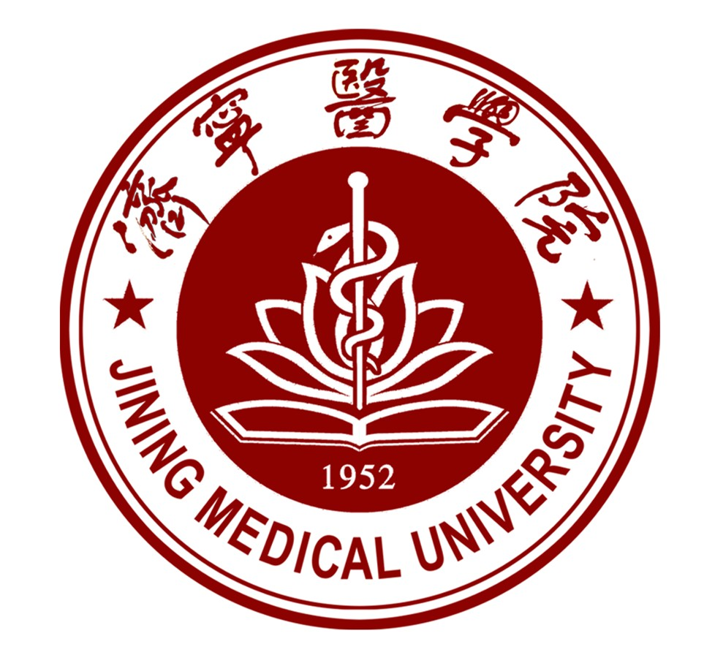 | 济宁医学院  Jining Medical University
  中国山东省济宁市太白湖区荷花路133号
  Address: 133 Hehua Road, Taibaihu District, Jining City, Shandong Province, China
  Tel: 86-537-3616022
  E-mail: jyghc@mail.jnmc.edu.cn
  申请号：
  JW202：
  (以上由学校填写/above only filed by the university.)

外 国 留 学 生 申 请 表
照片
(photo)
APPLICATION FORM FOR INTERNATIONAL STUDENTS OF JNMU

请申请人先认真阅读本表第二页的注意事项，然后用中文或英文填写下列内容。
Please read CAREFULLY the IMPORTANT NOTES on page 2 before filling out the form.

1. 申请人情况／Personal Information：
护照用名／Name (Same as in Passport)：姓／Family name 名/Given name
中文姓名／Chinese name： 出生日期／Date of birth： 年/Y 月/M 日/D
国籍／Nationality： 性别／Gender 出生地点／Place of birth：
护照号码／Passport No.： 婚姻状况／Marital Status：
母语／Native language________________________________ 宗教／Religion：
母国家庭地址／Home Add. In your country: ________________________________________________________
母国电话／Tel in your country： 传真／Fax：
工作或学习单位/Employer or Institution Affiliated:
现家庭地址／Home Add. Now: 现电话／Tel. Now： E-mail：
最后学历／Highest Academic Degree Obtained： 职业／Occupation： Student

2. 受教育情况(填至申请日)/Educational background (to the time of application)：
学校 在校时间 主修专业 所获毕业证书及学位证书
Institutions Years attended(from/to) Field of study Certificate
___________________ ____________________ __________________
__________________ ____________________
3. 语言能力／ Language proficiency：(请用“很好”、“好”、“一般”、或“不会”自行评价并填入空格/ Evaluate your
ability as Excellent, Good. fair or Poor in the blank.)
会话 阅读 写作
Speaking Reading Writing
汉语／Chinese： __________________ ________________________
英语／English.： ______________________ _______________________ ___________________
其他／Other.: ______________________ _______________________ __________________
4. 来校学习专业／Field of Study in China：__________________________

5. 来校学习计划／Plan of study in JMU：(请在所选的项目方框内打“√”／Please indicate with a checkmark in the bracket.)
本科生／Bachelor’s degree candidate：R 硕士研究生／Master’s degree candidate：□
6. 申请在济医学习时间／Duration of study in JMU：
自／From 2025 年／Year September 月／Month 至／To 2031年／Year July 月／Month
7. 申请人经费来源／Source of financial support：(请在所选的项目方框内打“√”/Please indicate with a cross in the bracket.)
团体资助／Organization：□ 家庭资助／Family：□ 个人支付／individual：□
8. 推荐您来华的机构或个人／Please specify the organization or who recommends you to study in China：
名称或姓名／Name： 地址：／Address：
电话／Tel： 传真／Fax：_____________________ E-mail：

9. 申请人在华保证人或机构/The guarantor charging your case in China：
名称或姓名／Name： 地址：／Address：
电话／Tel：___________________ 传真／Fax：_______________ E-mail：_________________________
10．经济担保人或机构/Financial support will be provided by:
电话／Tel：______________________ 传真／Fax：_____________________ E-mail：

注意事项/IMPORTANT NOTES
申请人须保证／I hereby affirm that：
- 申请表中所填写的内容和提供的材料真实无误；
All information and materials given in this form are true and correct;
- 在校期间，遵守中国的法律、法规，不从事任何危害中国社会秩序及与本人学习身份不相符合的活动；
During my stay in China, I shall abide by the laws and decrees of the Chinese government, and will not participate in any activities which are deemed to be adverse to the social order in China and are inappropriate to the capacity as a student;
- 在学期间，遵守学校的 校纪、校规，全力投入学习和研究工作。
During my study in Q.U.,I shall observe the rules and regulations of the university, and will concentrate on my studies and researches, and will follow the teaching programs made by the university.
- 如违反上述保证将接受中国法律、法规或校纪、校规的惩处。
If I am judged by the Chinese laws and decrees and the rules and regulations of the universities as having violated any of the above, I will not lodge any appeal against the decisions of the relevant authority.

申请人签字／Signature of the applicant：___________________ 日期／Date：

